Why on Earth Study Worms?
- an essay by Rob Blakemore (December, 2008)

One hundred fifty years ago in “The Origin of Species“ Charles Darwin (1859) wrote:
“It is interesting to contemplate an entangled bank, clothed with many plants of many kinds, with birds singing on the bushes, with various insects flitting about, and with worms crawling through the damp earth, and to reflect that these elaborately constructed forms, so different from each other, and dependent on each other in so complex a manner, have all been produced by laws acting around us.”
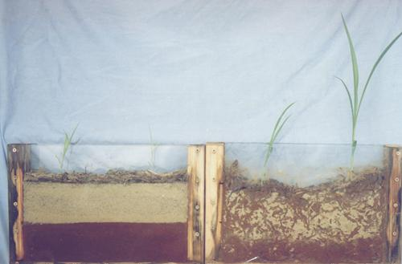
Two weeks after 5 worms added to rhs Sorghum mesocosm
(photo courtesy Dr Les Robertson).
ECOLOGY (the holistic study of organisms and their environment)
Earthworms are a particularly ancient, varied, and ecologically important group of organisms. Their progenitors, emerging in the late Precambrian some 650-570 million years (Ma) ago or possibly earlier, were amongst the first animals to leave the Oceans. ‘Bioneers’ in the colonization and preparation of the Land, they pre-date invasions by fungi, land-plants, insects (ca. 400-500 Ma), dinosaurs and mammals (ca. 200 Ma), they survived the K-T event, and occur well before the descendents of these early worms – the hominids – arose (ca. 4Ma). Earthworms are now ubiquitous in all but the driest of regions and the present-day world distribution of the 20 or so families have been explained in terms of Wegener’s (1912, 1915, 1922) hypothesis of Continental Drift. And, while the relative stability of the soil habitat at depth has enabled some ‘primitive’ forms to persist through the ages (akin perhaps to ‘living fossils”), the topographic vagaries allow more ‘advanced’ taxonomic varieties of species to develop.
Because they play a vital rôle in the formation and maintenance of healthy and fertile soils, earthworms are of paramount importance to Global Primary Production that sustains terrestrial life. The spread of Agriculture from Vavilov’s ‘Centres of Origins’ of crops can be traced by the earthworms from these regions following closely in the footsteps of our ancestors on their circuitous routes to Civilization. Their main contributions are moisture regulation, nutrient cycling and soil mixing. Associated with this activity is sequestration of Carbon in the fragile mantle of organic soil – SOM is the major sink for atmospheric C, more so than the Oceans or Forests combined – needed to redress deleterious anthropogenic effects of both Global Warming and Environmental Pollution. Ironically, the source of contamination is often the fossil fuels and toxic chemical by-product related to methods of Industrial Agriculture now including the intractability risk from GMOs that their lobbyists promote as alleviating environmental damage. Natural organic alternatives are IPM, Keyline, companion planting, cover crops, etc. or simply eating less red meat.
In his ‘other’ book: “Formation of Vegetable Mould [humus] through the Action of [Earth-]Worms with Observations on their Habits” praising the worm and its beneficial behaviours Darwin (1881) sagely states:
“It may be doubted whether there are many other animals which have played so important a part in the history of the world, as have these lowly organized creatures…”
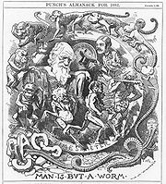
Darwin (1881) again showed that
“small causes produce great effects”.
TAXONOMY (nomenclature and phylogeny being different sides of the same coin)
Since Michaelsen's (1900) Das Tierreich: Vermes reviewed all 1,200 species of oligochaetes then known, taxonomic efforts have overwhelmed and polarized researchers either to the aquatic microdriles, or to the terrestrial megadriles – the ‘true’ earthworms. Current best estimate from Zoobank (Dec. ’08) of total Oligochaeta (microdriles + megadriles) is 12,212 catalogued species, genera and families; whereas Dr Csaba Csuzdi’s online database (2002) lists ca. 5,500 megadrile spp., and at least 400 subsequent names can be added, so that a reasonable total is ~5,900 megadriles. And, if we add the 3,600-4,400 or so mainly aquatic microdriles – determined from Dr Mark Wetzel’s website (2006) – this would give a total Oligochaeta of 9,500-10,300 spp. arranged in 804 Genera (+ 61 Sub-genera) and 38 Families, less an unknown number of synonyms but plus an indeterminable estimate of presently undiscovered or unearthed taxa.
In contrast, total Polychaeta number ~13,000 spp. (cf. Dec. ’08 Zoobank lists 21,260 names), although only 8,000 of these are considered reasonable species and these are in 1,000 Genera and 82 Families – this data from Dr Chris Glasby & Dr Kristian Fauchald’s POLiKEY website. (Dec. 2008).
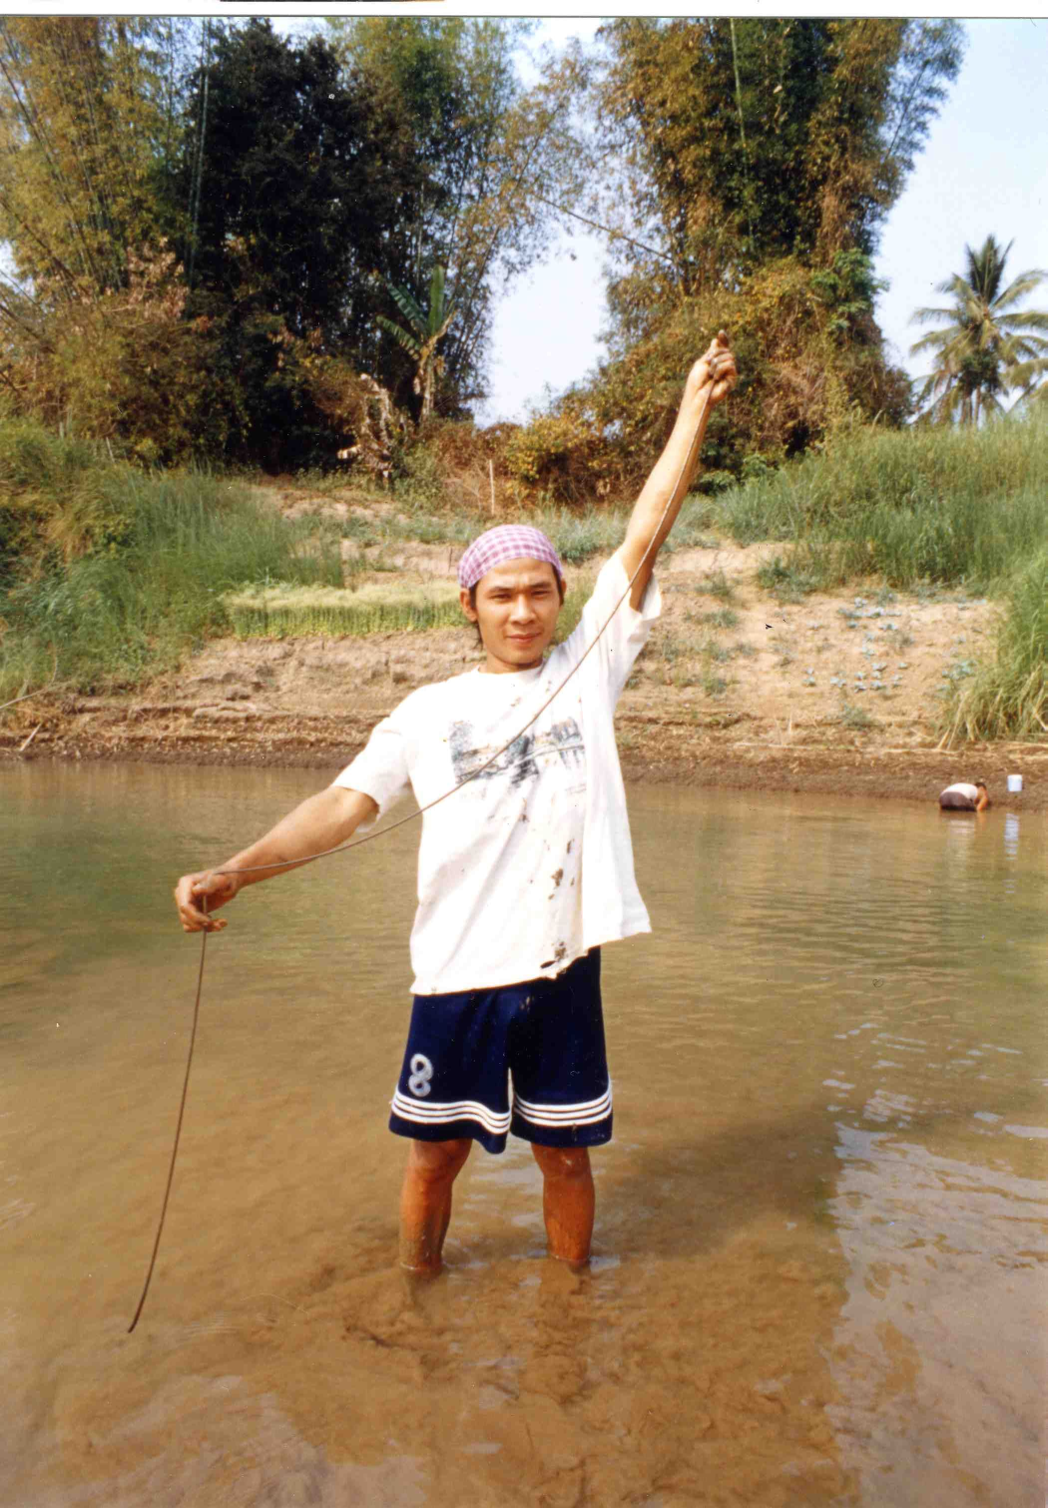
Collecting 3m long semi-aquatic Amynthas mekongianus in Laos
(photo courtesy T. Uchida).
ECO-TAXONOMY (merging of ecological survey with competent taxonomy)
“Eco-taxonomy” or ecological-taxonomy, as envisaged here implies combination of thorough ecological survey with competent taxonomic identification; including details of the species’ associations, its behaviour, life-cycle, and its external and internal (parasitic) habitats to represent the species in its complexity and its entirety, and the environment in its biodiversity and its community.

Contingency table of biodiversity sampling reliability
Case | Ecological  sampling | Taxonomic treatment | Results
1 | + | + | Representative data
2 | + | - | Under/over-estimate
3 | - | + | Under/over-estimate
4 | - | - | Unrepresentative data
+, Good; -, Poor

Apparent high diversity among marine polychaetes is due in part to the greater number of full-time researchers for this group; perhaps ten times as many as those working on Oligochaetes, with ~300 workers listed on the Polychaete Researchers Online PRO website (Dec. 2008). Even the lesser microdriles are quite well studied, e.g. an AQUATIC OLIGOCHAETOLOGISTS website [July, 2006] includes over 340 scientists from 54 countries. Considering that >99% of the world’s food (and fibre) supply is produced on Land, whereas only 0.6% comes from Oceans and other aquatic ecosystems (FAO, 1991), under-funding of soil eco-taxonomic research in favor of aquatic taxonomic ventures or similar is arguably an unbalanced ecological and socio-economic decision.
Justification for study of marine Polychaeta, quoted from POLiKEY [website: Dec. 2008], is along the lines that:
“Polychaetes are an important group both ecologically and economically. Ecologically, they are at (or near) the base of many food chains involving commercially important fish and shellfish species, they are common commensal organisms, they play a major role in nutrient recycling, some tubiculous species are reef builders, boring species are reef destroyers, and some species are bioindicators of the health of marine ecosystems. Polychaetes are also an important economically in both positive and negative ways. Species of Nereididae, Glyceridae, Onuphidae and Eunicidae are cultured or wild-harvested for bait or for use as feed in fish and shellfish mariculture. Parasitic species may have a negative effect on the shellfish (e.g. oysters) and others have a negative effect on shipping (hull fouling) and power stations (fouling water intake pipes). From a scientific point of view, polychaetes are a key group in phylogenetic studies of the evolution of complex invertebrates and a model group in studies of invertebrate reproduction and development.
Polychaetes are an ancient group dating back to the Middle Cambrian (540 million years ago), and possibly earlier. However, because they do not fossilise well - usually only the jaws, chaetae, tubes and burrows leave imprints - there are large gaps in the fossil record. To date, about 13,000 polychaete species have been described for the world. The actual number of species is estimated to be 25,000 to 30,000 (Mackie, Parmiter & Tong 1997). So, probably there remains over half the actual number of polychaetes to describe”.

If this is true for Polychaetes, then how much greater is the ecological and economic importance of the Oligochaetes? Being high in protein and moisture, they form the basis of many terrestrial food-webs (“no worms – no song-birds”), their activities are key to nutrient recycling necessary for plants and other soil organisms, and a few species are commercialized in vermicomposting and fishing bait industries. Conversely, certain other species have deleterious effects by acting as intermediate parasitic hosts, or due to their burrows draining terraced rice paddies. Yet overwhelmingly worms are regarded as vital bioindicators, recognized from earliest times by farmers and gardeners as a meter of good soil. In addition to their intrinsic Scientific merits and manifest worth, earthworms have a folkloric pharmacology with 4,000 years traditional medicinal use in China, and offering potential as a future bioprospecting resource exploiting their thrombolytic properties or both anti-tumor and anti-biotic competence (eg. Cooper, 2005 and website).
Taxonomic resolution of the Oligochaeta, if equable funding were to support earthworm eco-taxonomy at dedicated “Institutes of Soil Science” (comparable to the many marine laboratories around the Globe) and through the efforts of several full-time workers, may yet prove equivalent in species to the Polychaeta; and relative merit of earthworm study in other regards relates to the tangible fact that nobody actually lives in the Ocean.
The Earth is 70% ocean, but we depend on the other 30% of the land for most of our goods, ecological services and esthetics (i.e., food, fibres, renewable energy, nutrient recycling, biodiversity, air and water purification). Soil-based plant productivity supports our survival yet Soils, not Space nor the Oceans, are described as the “Final Frontier” and our knowledge of what occurs just beneath our feet is yet poorly known (Shand, 1997; Science 11th June, 2004).
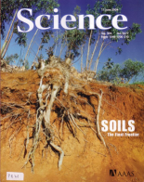
At the very time Soil Ecologists are beginning to uncover the magnitude and importance of life in the soil, this resource is being lost and degraded due to human activities.
Only when thorough eco-taxonomy study allows true biodiversity to be determined can we begin to appreciate and monitor the implications of sustainable communities of soil organisms have in supporting the foundation of terrestrial life that derives from healthy soil; or project the consequences if we destroy the thin topsoil that would augur our own demise.
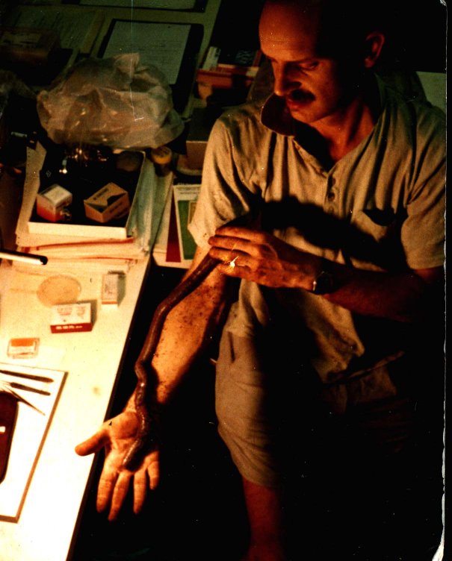
A large but friendly Queensland worm, Digaster sp.
(author).
ONLINE ECO-TAXONOMIC RESOURCES and INFORMATICS
In this era of informatics, it makes sense to have but a single definitive database of current, complete and correct Linnaean binomial names (with their authority, provenances, known distributions and pertinent ecological information) to which new names may be accepted (or rejected!) as soon as proposed. A Nomenclator is an objective but static list that simply catalogues names, while a Checklist of valid names includes subjective synonyms (that may yet be resurrected in order of priority) and is thus more useful. A third category of Enhanced Checklist, as compiled herein, list valid names and synonyms, as well as any misspellings, lapsae or nomena nudae so that an online search will stand a better chance of a ‘hit’. An ambitious aim for a similar database is by uBio's NameBank: a "biological name server" focused on storing names and objectively-derived nomenclatural attributes as a repository for all recorded names including scientific names, vernacular (or common names), misspelled names, and ad-hoc nomenclatural labels that may have limited context while serving nomenclatural concepts as XML objects - see http://uio.mbl.edu/nameserver/index.html.
Airy-Neave’s Zoological Nomenclator of genera names is online here, and species names are listed on Thomson-Reuter’s BIOSIS Index to Organism Names (the “ION” nomenclator that is now relaunched on http://www.organismnames.com with the seach facility here), or on the GBIF name search (includes some museum collection databases). The ION database has over 1.4 million animal names, at all taxonomic ranks, reported from the scientific literature since 1978 but the system will not deliver a list of valid organism names (cf. Species 2000 an international project with this intention to eventually provide a partial checklist to some species, see http://spice.sp2000.org/search.php). Other sites worth watching for development are Zootaxa, Zookeys, Encyclopedia-of-Life, Tree-of-Life, Taxonomicon and Wikispecies. Genbank list DNA nucleotide sequences for species without quality control checking for accuracy of the name.
As noted above, an initiative under the auspices of ICZN in collaboration with Zoological Records is ZooBank – a universal register of all animal names. Other initiatives are TDWG, TaxonX, TaXMLit, DarwinCore and so on (see Penev et al., 2008).
British BIOME website used to link to Museum collections and databases worldwide here.
Csaba Csuzdi’s Hungarian database of most earthworm species names up to 2002 is here.
Examples of eco-taxonomic biodiversity information concerning the “humble” Earthworm either for discrete family groups or for various regions of the Globe are provided for in the current Series of Chapters.
An answer to the original question, Why Study Worms? may well be: “OK they don’t look all too cute, but they mostly do no harm and probably are very important - for the Earth”. Hence their name.

-oOo-

Sources and details for the information presented here may be obtained from Blakemore (2002; 2006; 2008), Cosmopolitan Earthworms CD or Blakemore, R.J. (2009 in press): Invasive or peregrine earthworms – a global and historical perspective. Chapter 14 in: Annelids as Model Systems in the Biological Sciences, by Daniel H. Shain (ed.), John Wiley & Sons, Inc., N.Y. Pp. 257-283.
-oOo-

